|  |  |  |  |
| --- | --- | --- | --- |
| **Identification** | | | |
| **Project ID:** | 4321 | **Phase:** | 01 |
| **Version:** | 1 | **Date:** | 12/28/2022 |
| **Project Sponsor:** | COMSATS University | | |
| **Project Manager:** | Maam Sadia Maqbool | | |

# Introduction

## Purpose of Project Management Plan

A Breath disease detection system project charter is a document that outlines the purpose, goals, and key stakeholders of a project to develop an detection system that uses voice recognition technology. The main motive of developing a breath disease detection system (BDDS) is to help patients to detect breath related diseases(asthma, lung cancer, COPD(chronic obstructive pulmonary Disease ),COVID-19) while sitting at their home by using smartphone. The proposed system will help patient know exactly which disease they are suffering so that they can tell the doctor right disease to diagnose.

The goals of a voice recognition ecommerce project charter might include improving the user experience by making it easier for user to detect breath diseases, increasing user satisfaction and loyalty, and help patient to detect disease at early stage. Key stakeholders in this type of project might include the doctors, the development team responsible for building the voice recognition system, and the patients who will use the system to detect disease. The project charter should also outline the scope of the project, including any limitations or constraints that may impact the development and implementation of the system. It should also define the roles and responsibilities of the various team members and stakeholders involved in the project, as well as the timeline and budget for the project.

# Executive Summary of Project Charter

The purpose of this project is to develop a detection system that will help patients to detect breath related disease while sitting at their homes using smartphones. The system will provide patient with access to check the probability of the disease for which they are suffering as well as recommend them some medicine which will give them relief for time being and also facilitate them with the feature to chat with doctor with the help of chatbot.

The project will be completed in two phases: the first phase will focus on building the basic functionality of the system, and the second phase will focus on adding additional features and functionality. The project is scheduled to be completed in 12 months. Stakeholders will consist of a project manager, developers, a designer, and a quality assurance lead. The project will be overseen by a steering committee consisting of representatives from the university's IT department and student affairs office. The project will be governed by a set of defined processes and procedures, including a project management plan, a risk management plan, and a quality management plan.

**3 Scope Management**

Breath disease detection system is a web application as well as a mobile application to detect breath related disease at early stage. Our system will focus on four main diseases sand all the operations related to it. Our system will provide an interface for both the patient and doctors and give them as many functionalities of a hospital as we can. Patient and doctors both can easily register themselves from home without going through a long, time taking and inconvenient registration process at the hospital.First of all user(patient) enter the system by login into the system. The system will display list of all the diseases available in the system. After that user(patient) can select a disease to detect. Then system will display result of detection and display a report of disease with which user is suffering from. These reports will assist the doctors in proceeding the treatment of the patient. Then system will recommend medical suggestion to user for cure of disease for time being. User(patient) can also set alarms for taking medicine at specific time and days. The system can detect four major diseases which include Asthma, Lung cancer,COVID-19,COPD. The system will detect Asthma with the help of sound detection any abnormality in sound will detect Asthma. Lung cancer is detected with the analysis on chest radiographs which can achieved through ML by gathering datasets of different patients. The system is also capable of detecting COVID by analyzing X-rays of patients through ML. The system will detect COPD by analyzing the crackling sound of patient through ML. The system is 70 percent accurate.

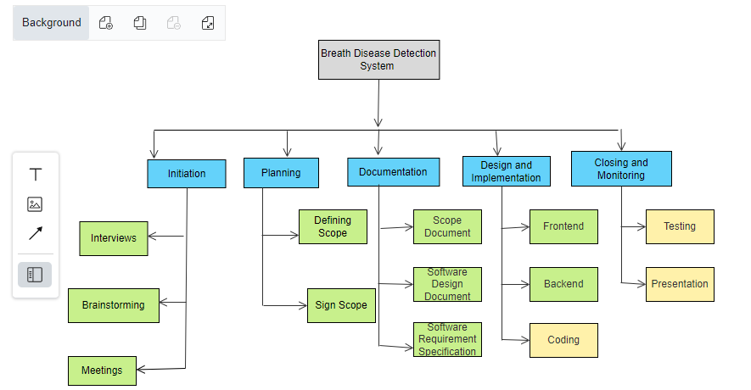

# 4 Schedule/Time Management

**4.1 Milestone schedule**

A milestone is a specific point within a project’s life cycle used to measure the progress toward the ultimate goal. Project management milestones should mark the five phases in the project life cycle: initiation, planning, Documentation, implementation, and closure.

According to our final year project there are several milestones that we are going to achieve. Following are the table given that show the our Fyp milestones.

|  |  |  |
| --- | --- | --- |
| **Date** | **Event** | **Priority (Low, Medium, High)** |
|  | **Initiation** |  |
| 3/10/2023 | Meetings and Interviews | Low |
|  | **Planning** |  |
| 5/8/2023 | Sign Scope or approved project | High |
| 5/15/2023 | Requirement Gathering and analysis | Medium |
|  | **Documentation** |  |
| 6/19/2023 | SRS Documentation | High |
| 8/14/2023 | SDS Documentation | High |
|  | **Implementation** |  |
| 9/11/2023 | Module 1: Patient Profile Management | High |
| 10/9/2023 | Module 2: Lung Cancer Detection | High |
| 11/6/2023 | Module 3: COVID Detection | Low |
| 12/4/2024 | Module 4: COPD Detection | Medium |
| 1/9/2024 | Module 5: Chatbot | High |
| 2/6/2024 | Module 6: Asthma Detection | Medium |
| 3/5/2024 | Module 7: Infobox | High |
| 4/2/2024 | Module 8: Checkup | High |
| 5/1/2024 | Module 9: Medicine Recommendation | Medium |
|  | **Closing** |  |
| 5/10/2024 | Unit Testing | Low |
| 5/20/2024 | Integration Testing | Medium |
| 5/29/2024 | System Testing | High |
| 6/18/2024 | Evaluation and Presentation | High |
| 7/1/2024 | Deployment | Medium |

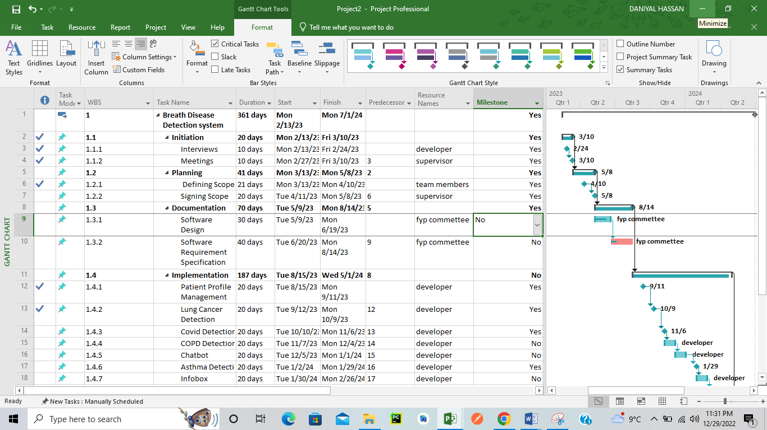

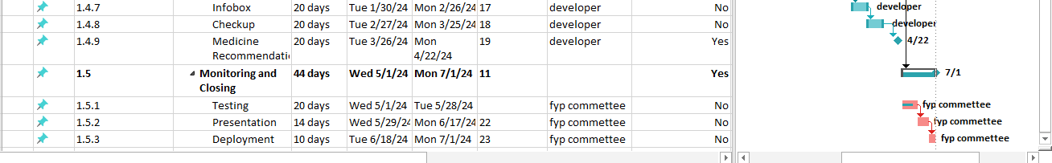

**4.2 Project schedule**

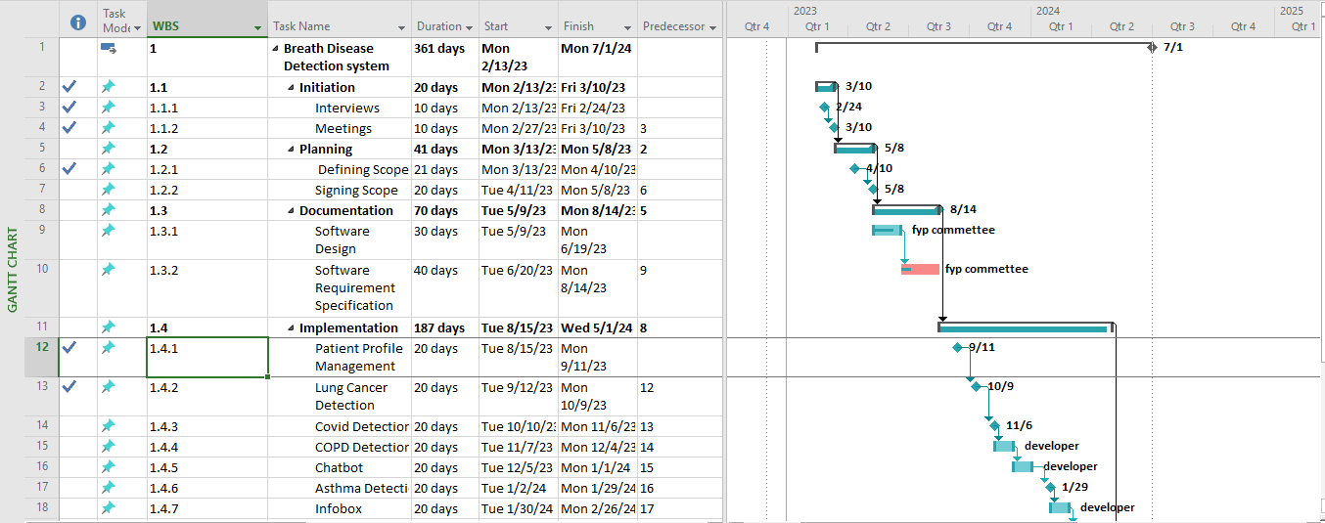

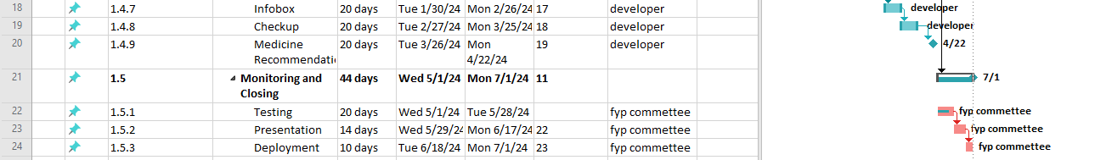

**5 Cost /Budget Management**

|  |
| --- |
| **Budget** |
| *Detail the budget by describing costs related to labor, purchasing materials, and any other costs* |

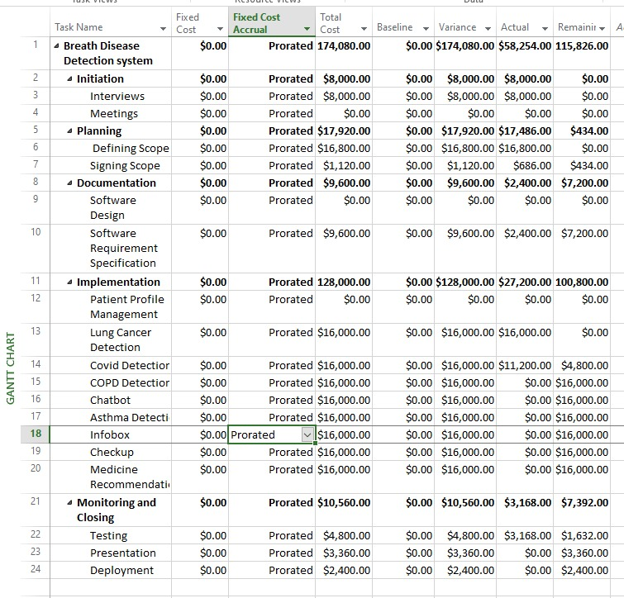

|  |  |  |  |  |
| --- | --- | --- | --- | --- |
| **Labor** | | | | |
|  | | | | |
| *List any incurred expenses as a result of labor. Note that in house labor does not need to be calculated and is not considered part of the budget. Only labor that requires additional payment beyond already existing labor costs is needed (i.e. outsourcing, additional help, designers, etc.)* | | | | |
| **Name** | **Position** | **Hours** | **Wages** | **Total** |
| Outsourcing Modules | 2 | 40 | $20k | $20k |

|  |  |  |  |
| --- | --- | --- | --- |
| **Purchasing Materials** | | | |
| *List any major purchases of materials that the project will need.* | | | |
| **Item** | **Quantity** | **Cost** | **Total** |
| Asthma Dataset | 10K images | 50$ | 50$ |
| COPD Dataset | 20K images | 100$ | 100$ |
| COVID Dataset | 1K images | 35$ | 35$ |
| Lung Cancer Dataset | 2K images | 45$ | 45$ |
| Draw.io.pro | 1 month usage | 10$ | 10$ |
| GPU for training | N/A | 55$ | 55$ |

|  |  |  |  |
| --- | --- | --- | --- |
| **Other Costs** | | | |
| *List any other costs the project will need to incur. This includes permits, rights, and anything else not included in the first two categories.*  *Or List the cost and effort required to achieve the function points etc.* | | | |
| **Item** | **Quantity** | **Cost** | **Total** |
| Utility Bills | 4 | 40$ | 40$ |
| Meetings Arrangements | 5 | 100$ | 100$ |

**6 Communication Management**

1. Internal Communication:

* Designate a project manager or team lead to oversee communication between team members.
* Establish a communication protocol to ensure that all team members are aware of their tasks, deadlines and any changes that may arise.
* Set up a regular schedule for meetings, both in-person and virtual, to ensure everyone is on the same page and to discuss any concerns or issues.

1. External Communication:

* Establish a communication plan with stakeholders and clients to ensure that they are aware of the project’s progress and any changes that may arise.
* Create an effective communication process between project team and stakeholders/clients, so that both parties are aware of their responsibilities and any decisions that need to be made.
* Establish a communication timeline to ensure that stakeholders and clients are updated with project progress in a timely manner.
* Set up a process for collecting feedback from stakeholders and clients to ensure

|  |  |  |  |
| --- | --- | --- | --- |
| **Stakeholder** | **Information** | **Delivery Mode** | **Frequency** |
| Project Manager | Project Charter | Document | Meeting |
| Project Manager | Scope Document | Document | Meeting |
| Project Manager | SDS | Document | Meeting |
| Project Manager | SRS | Document | Meeting |
| Project Manager | Implementation | Presentation | Meeting |
| Project Manager | Testing | Presentation | Meeting |
| Project Sponsor | Project Charter | Document | Online |
| Project Sponsor | Scope Document | Document | Online |
| Project Sponsor | SDS | Document | Online |
| Project Sponsor | SRS | Document | Online |
| Project Sponsor | Implementation | DVD or CD | Meeting |
| Evaluation Committee | Implementation | Presentation | Interview |

# 7Quality Management

|  |
| --- |
| **Quality Assurance Planning** |
| *Describe the Quality Assurance Plan and list any documents (QA Plan, Test Scenarios, Test Scripts, etc.) that comprise the overall Quality Assurance Plan.* |

It typically includes a description of the quality standards that will be used to evaluate the product or service, as well as the methods and tools that will be used to test and verify that these standards are met.

Here are some common documents that might be included in a QA plan:

1. QA plan: This document outlines the overall approach to quality assurance, including the quality standards that will be used, the testing processes and procedures, and the roles and responsibilities of team members.

2. Test scenarios: These documents describe the specific tests that will be conducted to verify the functionality and performance of the product or service.

**8 Change Management**

|  |
| --- |
| **Change Control Procedures** |

There are several procedures that can be put in place to manage changes within a project. Here are a few potential steps that can be taken:

1. Create a formal process for requesting and reviewing changes to the project. This could involve creating a change request form and establishing a review committee to evaluate the impact of the proposed change on the project.
2. After the change has been implemented, it is important to conduct a formal review to assess the impact of the change on the project and to identify any lessons learned. This can be done through a post-implementation review or by collecting feedback from stakeholders.

|  |
| --- |
| **Acceptance Management** |

User acceptance can be achieved through various procedures, such as:

1. **Developing project plans**: Developing a clear and detailed project plan that outlines the deliverables and the acceptance criteria for each deliverable.
2. **Conduct user testing**: User testing can be an effective way to gather feedback on the usability and functionality of a deliverable. This can be done through usability testing, where users are asked to complete specific tasks using the deliverable, or through alpha and beta testing, where a group of users are given access to a test version of the deliverable
3. **Monitor and track user feedback:** After the deliverable has been deployed, it's important to continue monitoring and tracking user feedback to identify any issues or areas for improvement. This can be done through surveys, user interviews, and other methods.

|  |
| --- |
| **Activity-Responsibility Matrix**  *Participation Codes: E = Execution; A = Approval Authority; C = Consult; I = Inform* |

|  |  |  |
| --- | --- | --- |
| **Activity** | **Name(s) Involved** | **Participation**  **Code** |
| Develop Course Outline | Daniyal | A |
| Develop Couse Outline | Ahmed | I |
| Develop Course Outline | Ali | E |
| Develop Course Outline | Sarmad | C |
| Performance Test | Daniyal | C |
| Performance Test | Ahmed | A |
| Performance Test | Ali | E |
| Performance Test | Sarmad | I |
| Schedule Regression Test | Daniyal | I |
| Schedule Regression Test | Ahmed | A |
| Schedule Regression Test | Ali | C |
| Schedule Regression Test | Sarmad | E |
| Publish Test Results | Daniyal | I |
| Publish Test Results | Ahmed | A |
| Publish Test Results | Ali | E |
| Publish Test Results | Sarmad | C |

**9 Risk management**

9.1 Risk assessment

|  |  |  |  |
| --- | --- | --- | --- |
| **Risk Assessment** | | | |
| *Identify areas that pose a potential risk toward the success and completion of the project. These events should be identified as those that threaten the goals, budget, and timetables of a project. Actual risks encountered should be logged in the* ***RISK LOG*** *in the project management folder.* | | | |
| **Risk Event** | **Possible Factors Effected**  **(i.e. budget, time, scope)** | **Potential Impact (Low, Medium, High)** | **Probability (Low, Medium, High)** |
| **UX Design Not Accepted** | **Scope** | **Low** | **Low** |
| **Developer leaving from organization** | **Time** | **High** | **Medium** |
| **Increase in Price by service provider** | **Budget** | **High** | **High** |
| **Changing Clients Requirements** | **Scope** | **High** | **Medium** |
| **Wrong data send by Api** | **Time** | **Medium** | **High** |
| **Not enough of server power** | **Budget** | **Medium** | **Low** |

**9.2 Issue management**

|  |
| --- |
| **Issue Management** |
| *Define the methodology regarding issues during the project. How will issues be prioritized (low, medium, or high) and what characterizes each level or priority. Also, define issue escalation procedures. More specifically, when would an issue be escalated and to whom are they escalated to. Actual encountered issues should be logged in the* ***ISSUE LOG*** *in the project management folder.* |

|  |
| --- |
| **Organizational Chart** |

There are several different types of organizational structures that can be used for a project, including:

1. **Functional structure**: In a functional structure, team members are organized by their specific areas of expertise or functional roles, such as marketing, finance, or engineering. This type of structure is well-suited for projects that are focused on a specific function or area of the organization.
2. **Matrix structure**: In a matrix structure, team members are organized by both functional roles and project-specific roles. This structure allows for cross-functional collaboration and can be effective for projects that require input from multiple functional areas.
3. **Hybrid structure**: A hybrid structure combines elements of different organizational structures and can be customized to fit the specific needs of the project

|  |
| --- |
| **Stakeholder Training Plan** |

A training plan is a document that outlines the training and development activities that will be provided to stakeholders involved in a project.

Some factors to consider when defining which stakeholders apply to each training plan might include:

1. **Skills and knowledge**: Different stakeholders may have different levels of existing skills and knowledge, and may require different types of training to address their specific needs.
2. **Training objectives**: The training objectives may vary depending on the specific goals of the project and the needs of the stakeholders. For example, some stakeholders may require training on specific tools or systems, while others may need training on soft skills, such as communication or leadership.

|  |
| --- |
| **Implementation Transition Plan** |

A transition plan is a document that outlines the steps and actions required to successfully implement a project and transition it to the ongoing operation of the organization.

Here are some specific items that should be included in a transition plan to outline the steps required and the further action needed once the implementation is complete:

1. **Transition timeline:** The transition plan should include a timeline for the implementation of the project, including key milestones and deliverables. This will help to ensure that the transition is properly planned and coordinated and that all stakeholders are aware of the timeline for the transition.
2. **Communication plan:** The transition plan should include a communication plan to ensure that all relevant stakeholders are kept informed of the progress of the transition
3. **Training plan:** The transition plan should include a training plan to ensure that all relevant stakeholders are trained on the new systems, processes, or tools being implemented as part of the project.

Appendix A: Project Management Plan Approval

The undersigned acknowledge they have reviewed the *<Project Name>* **Project Management Plan** and agree with the approach it presents. Changes to this **Project Management Plan** will be coordinated with and approved by the undersigned or their designated representatives.

[List the individuals whose signatures are desired. Examples of such individuals are Business Steward, Project Manager or Project Sponsor. Add additional lines for signature as necessary. Although signatures are desired, they are not always required to move forward with the practices outlined within this document.]

|  |  |  |  |
| --- | --- | --- | --- |
| Signature: |  | Date: |  |
| Print Name: |  |  |  |
| Title: |  |  |  |
| Role: |  |  |  |

|  |  |  |  |
| --- | --- | --- | --- |
| Signature: |  | Date: |  |
| Print Name: |  |  |  |
| Title: |  |  |  |
| Role: |  |  |  |

|  |  |  |  |
| --- | --- | --- | --- |
| Signature: |  | Date: |  |
| Print Name: |  |  |  |
| Title: |  |  |  |
| Role: |  |  |  |